

2021 Year 12 ViSN Mathematics Specialist Unit 3
Test 2 – Functions
Section One – Calculator Free
Mr Daniel Comtesse  Mandurah Catholic College | Calculator Free:______/32  Calculator Assumed:_____/11
daniel.comtesse@cewa.edu.au | Result: _____/43 ______%

Student Name: ___________________________________________

School: ___________________________________________

Time allowed: Section One - 35 minutes

Section Two – 15 minutes

Assessment Date: 22 March 2021

Material required/recommended

To be provided by the supervisor
This Question/Answer Paper
SCSA Formula Sheet

To be provided by the candidate
Standard items: pens, pencils, pencil sharpener, eraser, correction fluid/tape, ruler, highlighters

Submission Details
Timed Assessments are to be returned to the ViSN teacher by the ViSN mentor (scan completed assessment and email to teacher above) within 24 hours of assessment date (above).
Instructions to Students

1. ALL questions should be attempted.
2. Write your answers in the spaces provided in this Question/Answer Booklet.
3. SHOW ALL YOUR WORKING CLEARLY. Your working should be sufficient detail to allow your answers to be checked readily and for marks to be awarded for reasoning. Correct answers given without supporting reasoning may not be allocated full marks. Incorrect answers given without supporting reasoning cannot be allocated any marks.
4. If you repeat an answer to any question, ensure that you cancel the answers you do not wish to have marked.
5. It is recommended that you do not use pencil, except in diagrams.

Question 1 [1, 3 = 4 marks]
Consider the function $f\left(x\right)={\left(x-2\right)}^{2}-3$.
- Explain why it is necessary to restrict the natural domain of f(x) so that its inverse is also a function.

- State a minimal restriction to the domain of f(x) that includes $x=1$, and then use this restriction to show that $f^{-1}\left(x\right)=2-\sqrt{x+3}$.

Question 2 [3, 3 = 6 marks]
The graph of $y=f(x)$ is shown below.
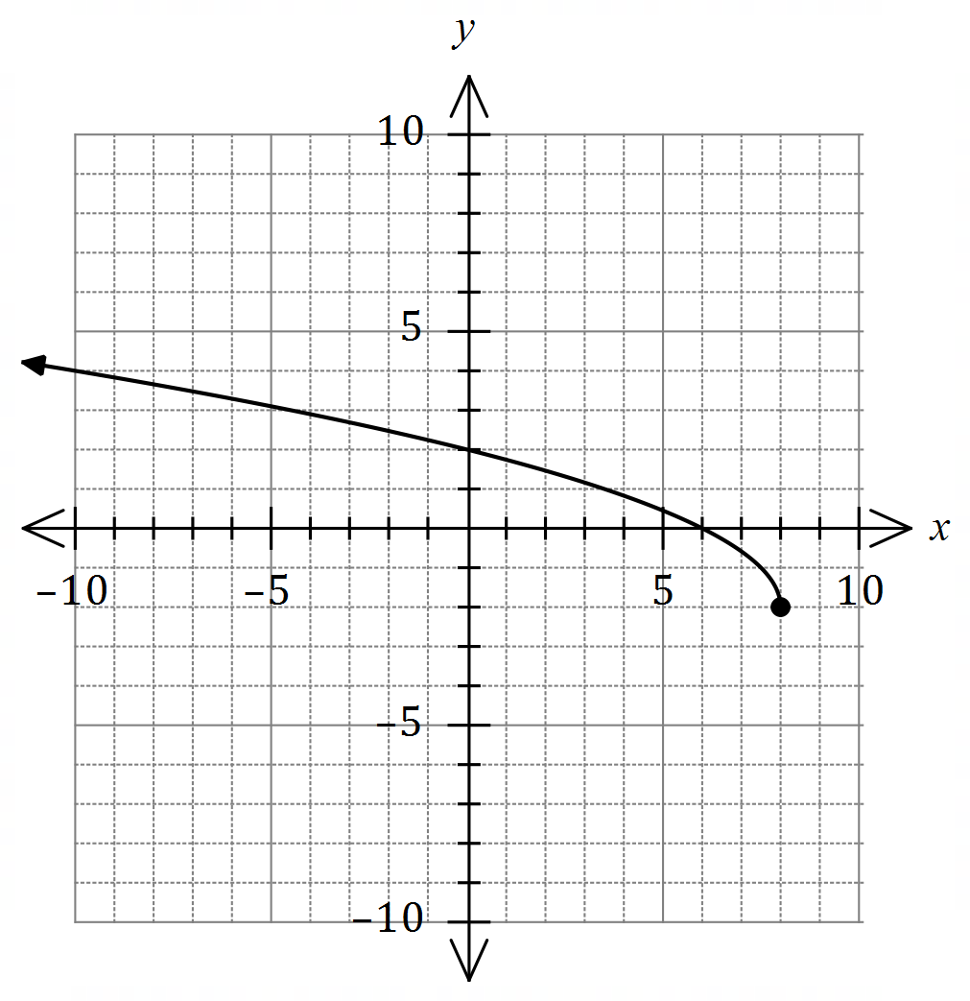

- Draw the graph of $y=f^{-1}(x)$ on the same axes.

- Given that $f\left(x\right)=\sqrt{16-2x}-2$, determine the defining rule for $f^{-1}(x)$.

Question 3 [1, 1, 2, 2 = 6 marks]
Functions $f, g$ and $h$ are defined as
$$f\left(x\right)=x+3, g\left(x\right)=\sqrt{x}, h\left(x\right)=\frac{4}{2-x} .$$
- Determine

- $h∘g∘f(6)$.

- the defining rule for $h∘g∘f(x)$.

- Determine the domain of $h∘g∘f(x)$.

- Determine the range of $h∘g∘f(x)$.

Question 4 [2, 2, 1, 3 = 8 marks]
The graph of $f\left(x\right)=\left|ax+b\right|+c$ is shown below.

(a) Using the graph, or otherwise, solve

- $f\left(x\right)=5$.

- $f\left(x\right)=x$.

- $f\left(x\right)+2x=3$.

(b)Determine the values of $a, b, c ∈Z.$

Question 5 [4 marks]
Let $f\left(x\right)=\begin{matrix}x^{2}-4x-2 \\ \overline{ x-1 }\end{matrix}$ . Sketch $f(x)$ on the axes provided below.
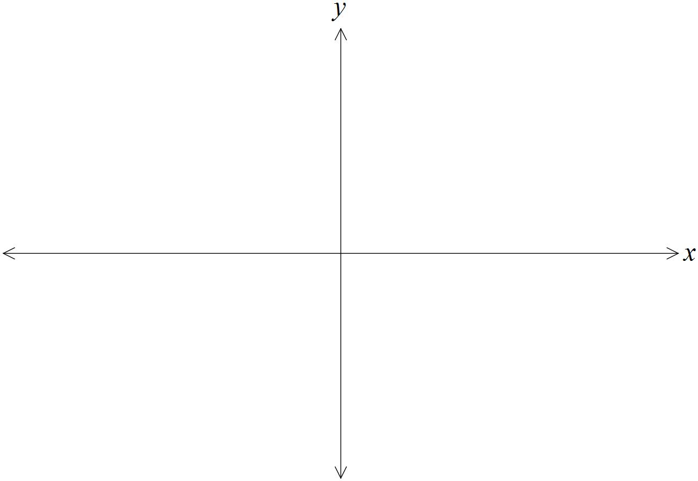
Question 6 [1, 1, 2 = 4 marks]
Let $g\left(x\right)=\begin{matrix}(x-2)(x+3) \\ \overline{{ x}^{2}+1 }\end{matrix}$ .

- State the equation of the horizontal asymptote of the graph of $y=g(x)$.

- State the values of $g\left(6\right), g(7)$ and $g(8)$.

- Use your previous two answers to explain why the graph of $y=g(x)$ must have a local maximum to the right of $x=7$.

End of Section One

Extra Working Space
Question number: _________


2021 Year 12 ViSN
Mathematics Specialist Unit 3

Test 2 – Functions
Section Two – Calculator Assumed
Mr Daniel Comtesse  Mandurah Catholic College | Calculator Assumed:_____/10
daniel.comtesse@cewa.edu.au

Student Name: ___________________________________________

School: ___________________________________________

Time allowed: Section One - 35 minutes

Section Two – 15 minutes

Assessment Date: 22 March 2021

Material required/recommended

To be provided by the supervisor
This Question/Answer Paper
SCSA Formula Sheet

To be provided by the candidate
Standard items: pens, pencils, pencil sharpener, eraser, correction fluid/tape, ruler, highlighters
Special items: scientific and/or CAS calculator, 1 A4 (one sided) page of notes.

Instructions to Students

1. ALL questions should be attempted.
2. Write your answers in the spaces provided in this Question/Answer Booklet.
3. SHOW ALL YOUR WORKING CLEARLY. Your working should be sufficient detail to allow your answers to be checked readily and for marks to be awarded for reasoning. Correct answers given without supporting reasoning may not be allocated full marks. Incorrect answers given without supporting reasoning cannot be allocated any marks.
4. If you repeat an answer to any question, ensure that you cancel the answers you do not wish to have marked.
5. It is recommended that you do not use pencil, except in diagrams.

Question 7 [2, 4, 1 = 7 marks]
The graph of $y=f(x)$ is shown below over the domain $-2≤x≤6$.

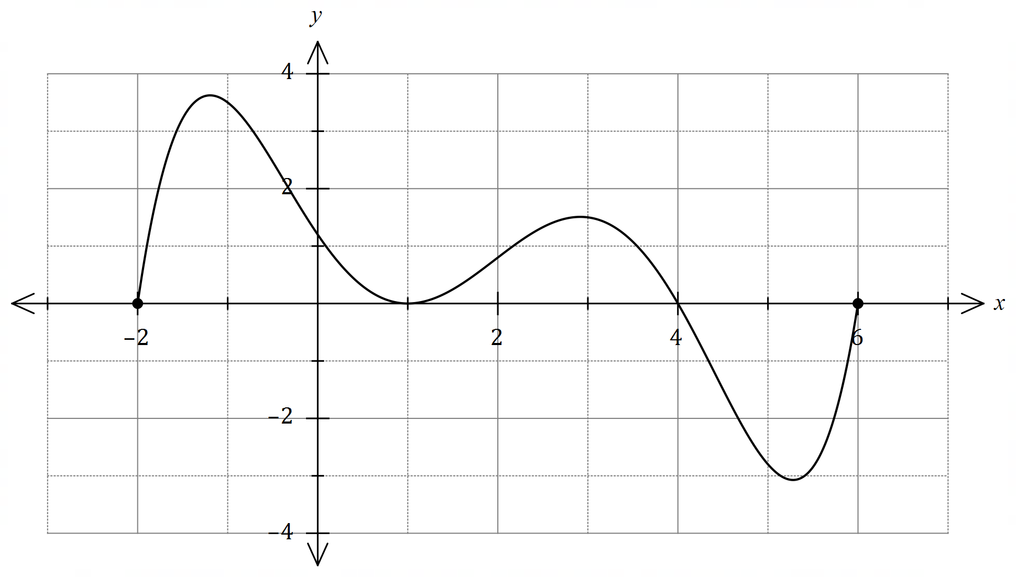

(a) Sketch the graph of $y=f\left(|x|\right)$ over the domain $-3≤x≤3$ on the axes below.

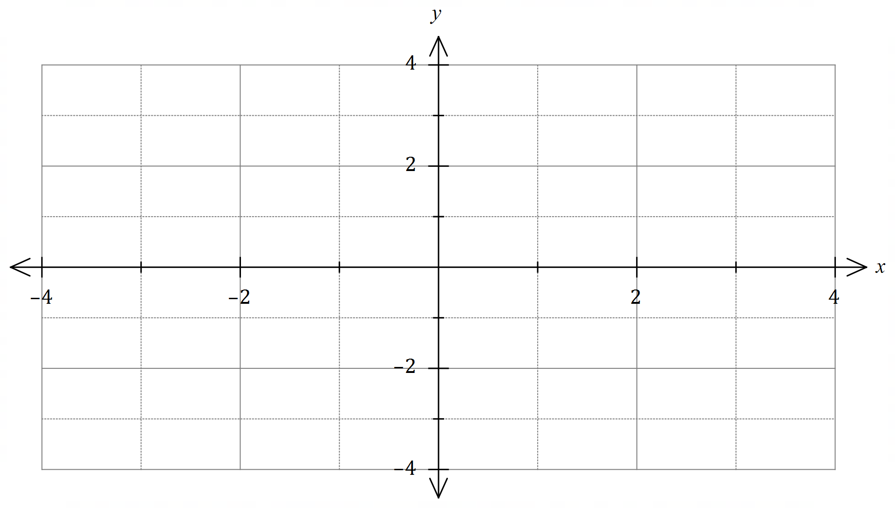

(b) Sketch the graph of $y=\begin{matrix}1 \\ \overline{f(x)}\end{matrix}$ on the axes below over the domain $0≤x≤5$.

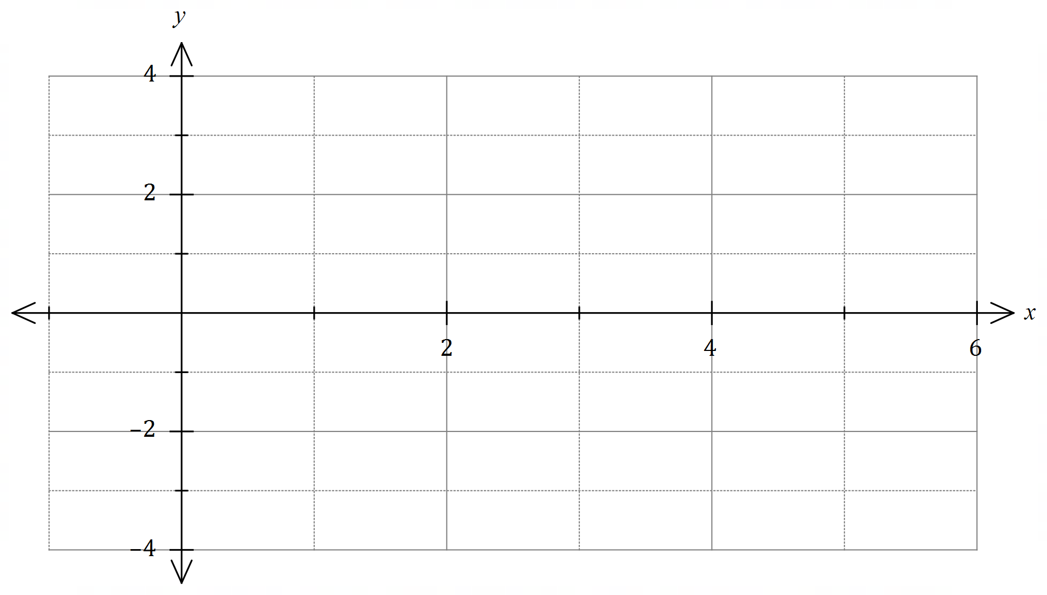

(c) Sketch the graph of $y=\left|f\left(x\right)\right|$ on the axes below over the domain $-1≤x≤6$.


Question 8 [3 marks]
The function $f(x)$ is graphed on the axes below with oblique asymptote $y=x-3$. Determine the equation for $f(x)$.

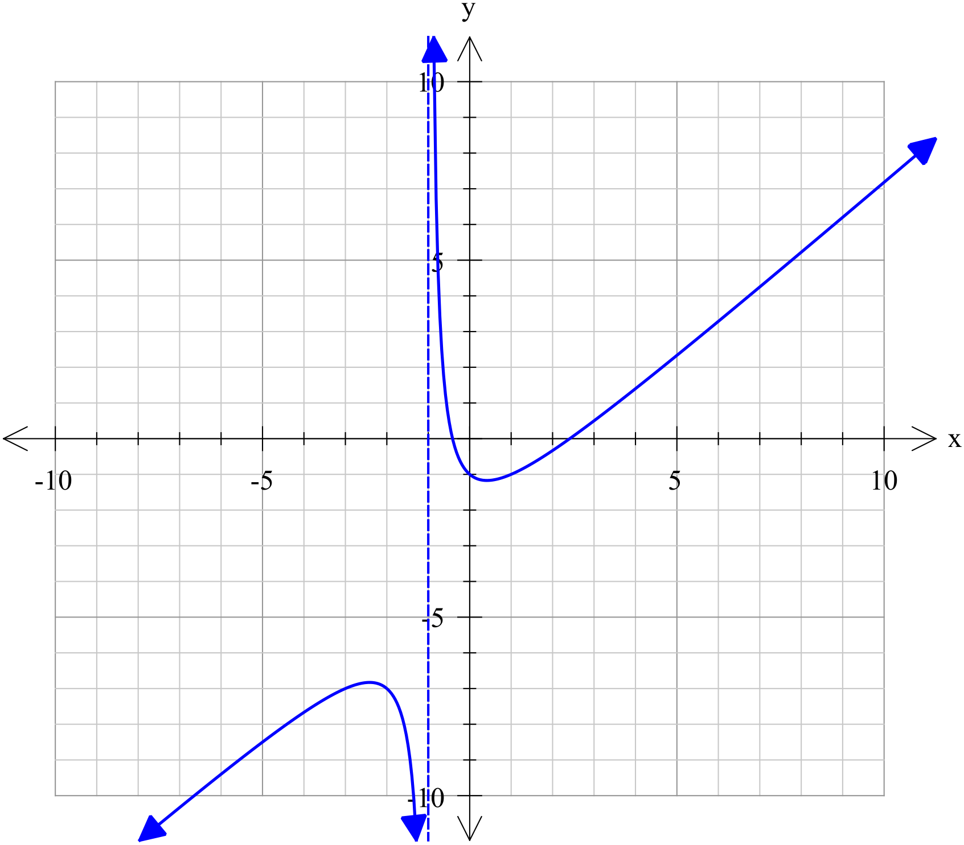

End of Assessment
Extra Working Space
Question number: _________

